**Description**

As a user, If I want to see more information about the team, I should be able to go on the Footer Section and click on the Company Directory Link and be directed to that page.

------------------------------------------------------------------------------------------------------------------------------------------



⇧

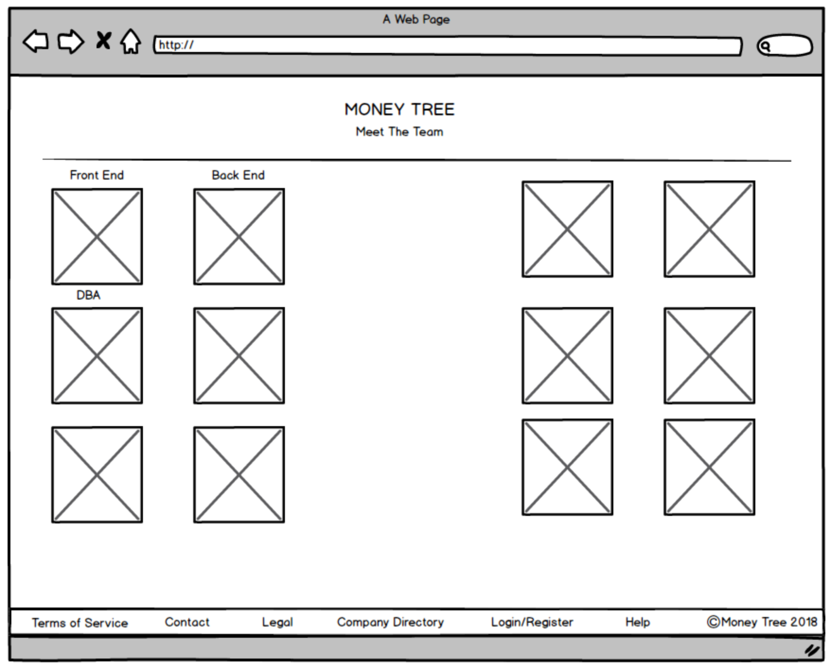

**Acceptance criteria**

* Display all team members with their Photos and Project Role Descriptions